CS 340 README

About the Project/Project Title
Animal Shelter CRUD Python Module
This project develops the database layer of a client/server application for Grazioso Salvare, an international rescue-animal training organization. Grazioso Salvare needs a way to work with animal shelter data to identify dogs that may be good candidates for different types of search-and-rescue training. The project uses the Austin Animal Center Outcomes dataset as the foundation for a MongoDB database containing animal records.

The Animal Shelter CRUD Python Module provides a reusable interface between Python applications and the MongoDB database. Using object-oriented programming, the AnimalShelter class establishes the database connection and provides Create, Read, Update, and Delete (CRUD) methods for managing records in the animals collection. Separating the database operations into a reusable Python module allows other client-side code to interact with the database without having to duplicate the MongoDB connection and CRUD logic.

Project One focuses on developing and testing this database layer. The database is populated using the provided animal shelter dataset, protected through an authenticated MongoDB user account, and accessed from Python through the PyMongo driver. The CRUD functionality is tested in Jupyter Notebook to verify that animal records can be created, retrieved, modified, and removed successfully. This database functionality will provide the foundation for the client-facing dashboard developed later in the project.

Motivation
The purpose of this project is to create a reusable Python module that simplifies working with MongoDB and allows database operations to be performed through Python.

Getting Started
To reproduce this project, MongoDB, Python, PyMongo, and Jupyter Notebook are required. The project also requires the provided aac_shelter_outcomes.csv dataset, CRUD_Python_Module.py, and ProjectOneTestScript.ipynb.

- The Austin Animal Center Outcomes CSV dataset was imported into the aac MongoDB database and animals collection using the mongoimport command. The completed import added 10,000 animal records to the collection.
- A MongoDB user named aacuser was configured with the readWrite role for the aac database. Authentication was tested to verify that the user could securely access the database.
- The CRUD_Python_Module.py file was developed using object-oriented programming. The AnimalShelter class establishes the MongoDB connection and contains methods for Create, Read, Update, and Delete operations. The Create method uses insert_one(), the Read method uses find(), the Update method uses update_many() with the $set update operator, and the Delete method uses delete_many().
- The ProjectOneTestScript.ipynb Jupyter Notebook imports and instantiates the AnimalShelter class using the authenticated database account. A test animal record is created and read from the database. The same record is then updated and read again to verify the changes before being deleted. A final Read operation confirms that the deleted record is no longer present.

During development, testing identified several syntax and typing errors that were corrected before the final execution. One issue involved the modified_count attribute used to return the number of documents changed by the Update method. After correcting the code, Jupyter Notebook continued using the previously imported version of the Python module. Restarting the Jupyter kernel reloaded the corrected CRUD_Python_Module.py file, allowing the complete CRUD test to execute successfully. Testing and exception handling were used throughout development to identify errors and verify that each database operation worked as intended.

Installation
Python, MongoDB, PyMongo, and Jupyter Notebook are used to develop and test this project.

Python is used to develop the reusable AnimalShelter class and implement the CRUD methods that allow client-side code to interact with the database.

MongoDB is the NoSQL database management system used to store the Austin Animal Center animal records. Its document-based structure allows records to be queried and modified without requiring a traditional relational table structure. The mongoimport utility is used to import the provided CSV dataset into the aac database and animals collection.

PyMongo is the Python driver used to communicate with MongoDB. It allows the Python module to perform database operations through methods such as insert_one(), find(), update_many(), and delete_many(). The Update operation uses MongoDB’s $set operator to change specified fields without replacing the entire document. PyMongo also provides modified_count and deleted_count, which are used by the module to report the number of documents affected by Update and Delete operations.

Jupyter Notebook provides an interactive environment for testing the CRUD module. ProjectOneTestScript.ipynb imports the AnimalShelter class and executes each CRUD operation so that the results can be reviewed immediately and verified against the MongoDB database.

PyMongo can be installed using:

pip install pymongo

Usage
The module provides Create, Read, Update, and Delete functionality for the animals collection. The Create method inserts a new document and returns True when the operation is successful. The Read method retrieves documents that match a specified query and returns the results as a list. The Update method modifies documents that match a specified query and returns the number of documents modified. The Delete method removes documents that match a specified query and returns the number of documents deleted.

Code Example
The following example demonstrates how the CRUD module can create a new animal record, retrieve the record, update its information, and delete it from the database.

test_animal = {
“animal_id”: “JAYTEST001”,
“name”: “Test Dog”,
“animal_type”: “Dog”,
“breed”: “Labrador Retriever”,
“color”: “Black”,
“age_upon_outcome”: “2 years”
}

# Create
shelter.create(test_animal)

# Read
shelter.read({“animal_id”: “JAYTEST001”})

# Update
shelter.update(
{“animal_id”: “JAYTEST001”},
{“name”: “Updated Test Dog”, “color”: “Brown”}
)

# Delete
shelter.delete({“animal_id”: “JAYTEST001”})

Tests
The CRUD module was tested in ProjectOneTestScript.ipynb using the animal ID JAYTEST001. The Create method successfully inserted the test animal and returned True. The Read method retrieved the newly created document from the AAC database. The Update method changed the animal’s name to Updated Test Dog and its color to Brown, returning a modified count of 1. A second Read operation verified that the changes were stored in the database. The Delete method then removed the test document and returned a deleted count of 1. A final Read operation returned an empty list([]), confirming that the document was no longer present in the collection.

Testing the complete Create, Read, Update, and Delete sequence verified that the AnimalShelter class could successfully perform each required database operation and return the expected results.

Screenshots

The following screen shots demonstrate the database setup, security, and functional CRUD operations completed for the project.

Figure 1. MongoDB Dataset Import
The Austin Animal Center Outcomes CSV dataset was imported into the aac database and animals collection using mongoimport. The execution confirms that 10,000 documents were successfully imported with zero failed documents.

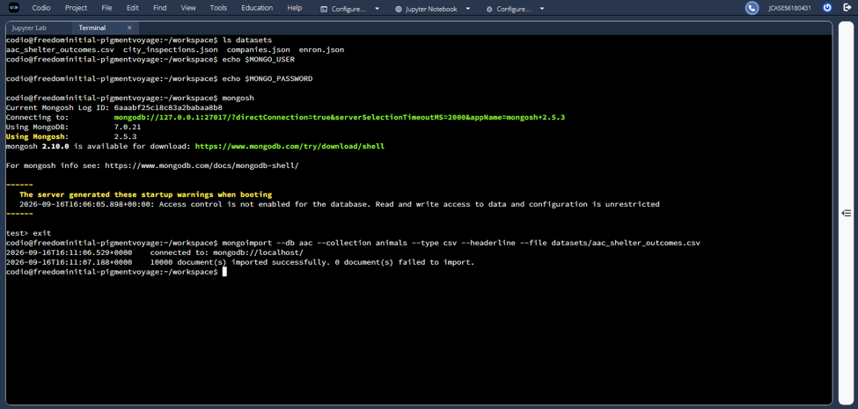

Figure 2. MongoDB User Authentication
The aacuser account was verified with the readWrite role for the aac database. Authentication returned ok: 1, and the connection status confirmed that aacuser was authenticated with the appropriate database permissions.

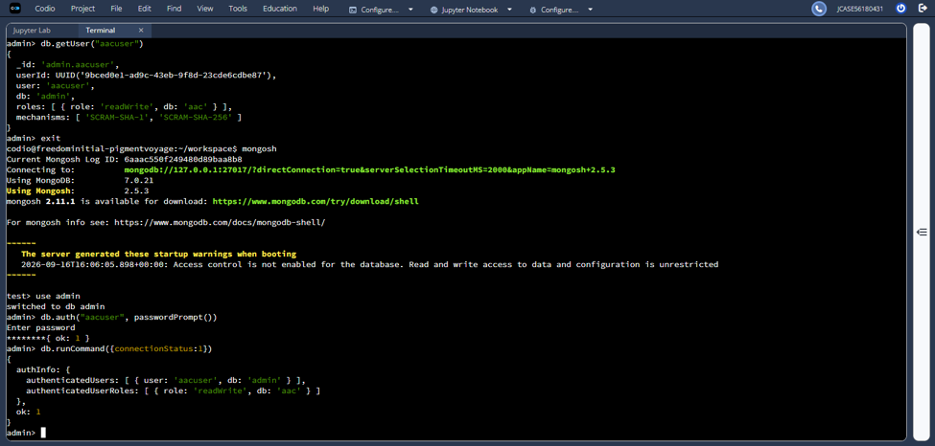

Figure 3. CRUD Functionality Testing
The completed CRUD module was tested in Jupyter Notebook. The output demonstrates successful creation and retrieval of the test animal, an Update operation that modified one document, verification of the updated values, a Delete operation that removed one document, and a final Read operation returning an empty list to confirm deletion.

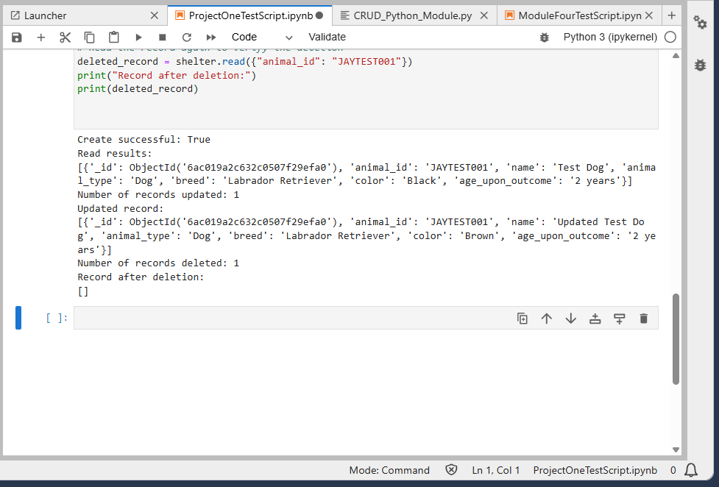

Roadmap/Features (Optional)
The current version of the Animal Shelter CRUD Python Module supports all four CRUD operations: Create, Read, Update, and Delete. MongoDB authentication is used to control access to the AAC database, and the completed CRUD functionality provides a reusable database interface for client-side applications.

The next phase of the Grazioso Salvare project will build on this database layer by developing the client-facing dashboard. The dashboard will use the CRUD module to interact with the animal shelter database and help users identify and categorize dogs that meet specific search-and-rescue training criteria. Additional testing and documentation will be completed as the database and dashboard are integrated into the full-stack application.

Contact
Your name: Jeremiah (Jay) Case

